Geometry Dash on SFML

(July 21) Stage 1: Make a running window with the square moving across the screen.
I initially wrote this as one big main loop, but realized I must break it into a main file and a player file since I must also implement jump, and gravity later on.

Player.h has the Player class, which has private variables box (a RectangleShape), and fload speed. The public section contains the construction and 2 functions other files are allowed to call:
Player();
void update(float deltaTime);
void draw(sf::RenderWindow& window);
The player.cpp initializes a player object using Player(), and sets the player box size, position, and color
The update function void Player::update(float deltaTime) moves the player frame by frame.
The draw function void Player::draw(sf::RenderWindow& window) draws the player rectangle on the screen
Main.cpp right now:
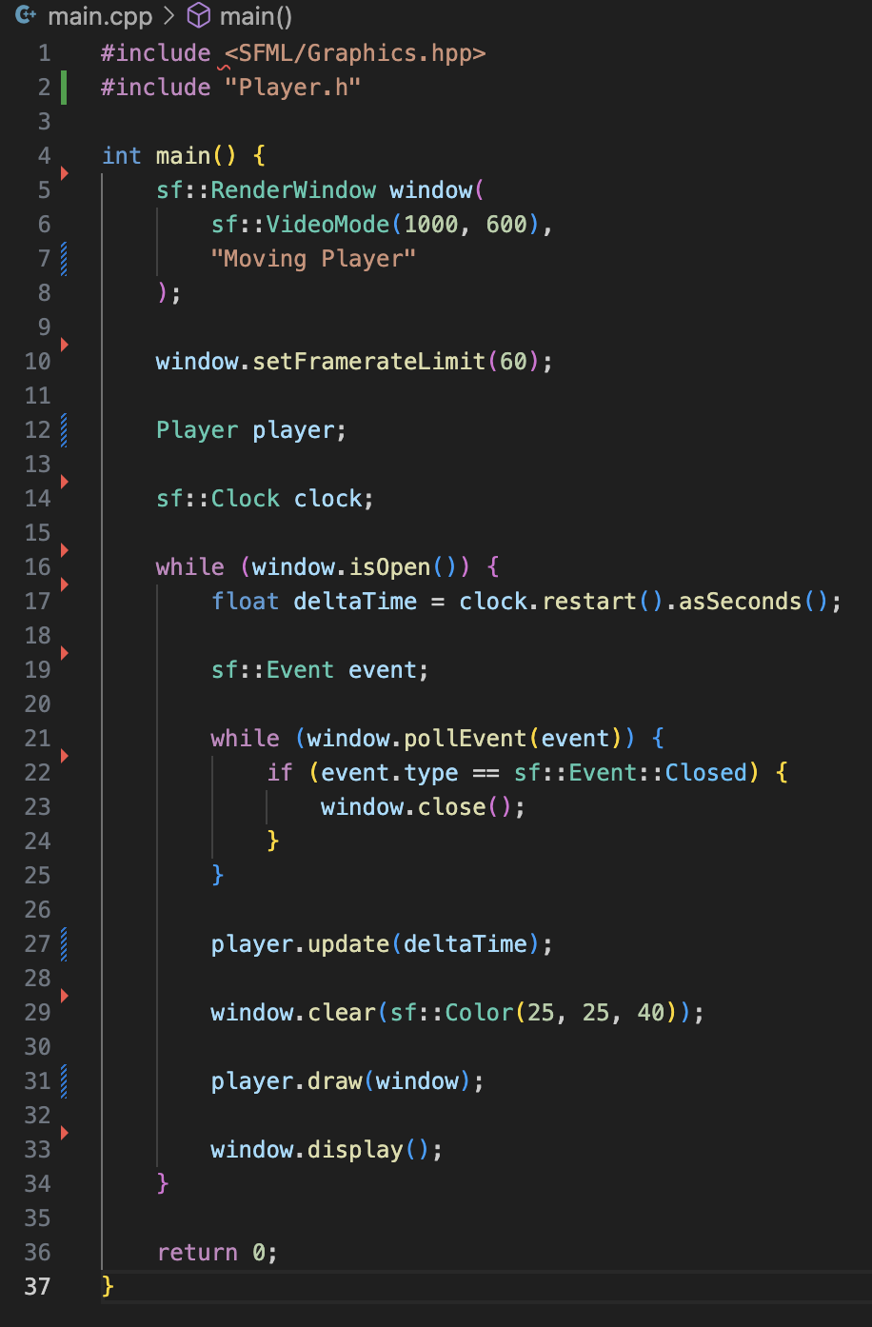
To run the program, run:
make clean
make
make run

(July 24) Stage 2: implement vertical velocity, gravity, a simple floor, and make sure the box (player) does not go through the floor.

